From: <https://www.unz.com/article/the-9-11-double-cross-conspiracy-theory/>

The 9/11 "Double-Cross" Conspiracy Theory

Pentagon Inside Job - World Trade Center Israeli Job

LAURENT GUYÉNOT • SEPTEMBER 6, 2022 • 8,100 WORDS • 1,578 COMMENTS •

Keywords: sayanim[[1]](#endnote-1) 7 results, Silverstein 10 results, double-cross 11 results, neocons 11 results, triangulation 3 results,

The 9/11 "Double-Cross" Conspiracy Theory

**The 9/11 "Double-Cross" Conspiracy Theory**

Top of Form

=>

Bottom of Form

[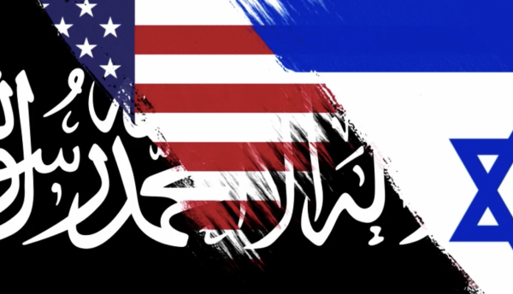](https://www.unz.com/article/the-9-11-double-cross-conspiracy-theory/)

[**9/11 for Dummies**](read://https_www.unz.com/?url=https%3A%2F%2Fwww.unz.com%2Farticle%2Fthe-9-11-double-cross-conspiracy-theory%2F#9-11-for-dummies)

Is it true that “9/11 was an inside job”? Yes, insofar as Israel is “inside” the U.S. But for the 9/11 truthers who have identified Israel as the main perpetrators, “9/11 was an inside job” is at best a half-truth, and at worst an integral part of the Zionist operation, like a secondary flag sewn as a lining under the false flag of Islamism. Victor Thorn (1963-2017) wrote in his book *9/11 made in Israel: The Plot Against America*(2011): “In essence, the ‘9-11 truth movement’ was created prior to Sept. 11, 2001 as a means of suppressing news relating to Israeli complicity. . . . The slogan ‘9-11 was an inside job’ was quite possibly the greatest example of Israeli propaganda ever devised.” In milder terms, it is “controlled opposition”.

A **genuine** truth movement would have pointed to Israel as the prime suspect from the start. From day one, it was obvious who would benefit. At 1 pm New York time on the day of the attacks, George Friedman (“born in Budapest, Hungary, to Jewish parents who survived the Holocaust,” Wikipedia informs us) wrote gleefully on his geopolitical website [STRATFOR](https://worldview.stratfor.com/article/israeli-dimension):

[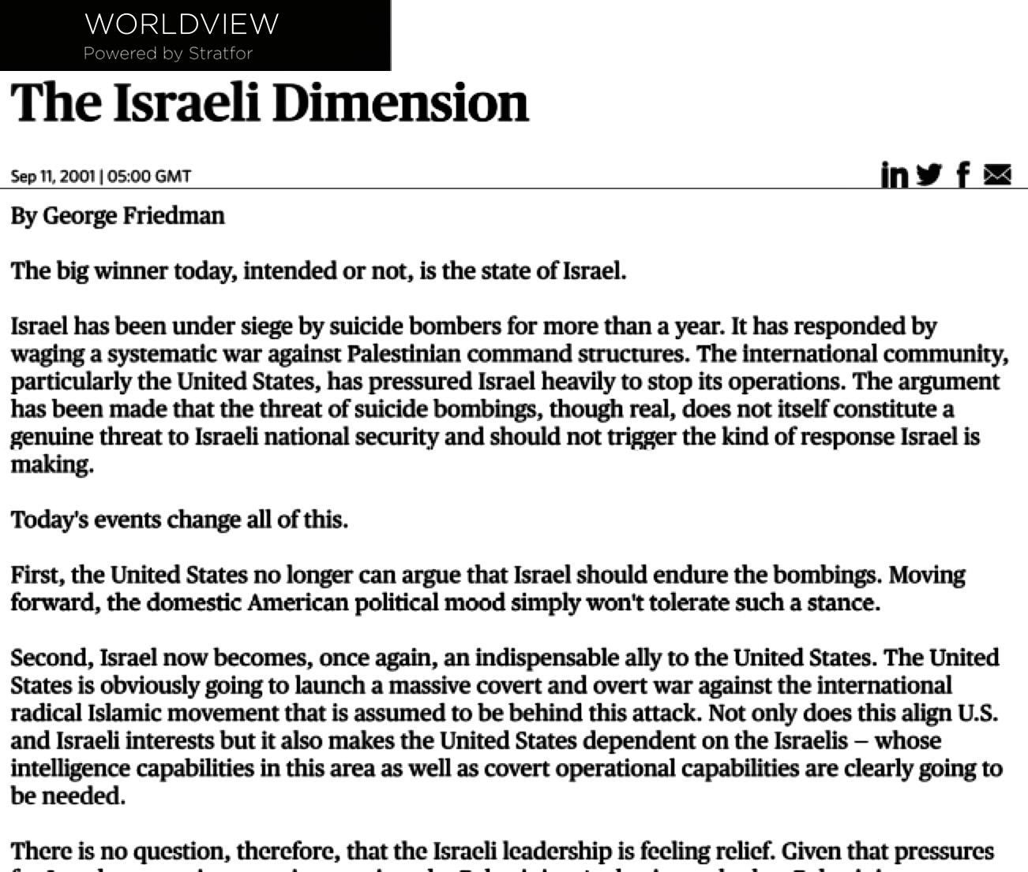](https://www.unz.com/wp-content/uploads/2022/09/DoubleCrossLG-2.jpg)

It’s pretty simple: 9/11 is best understood as a case of “triangulation”, by which two parties are drawn into conflict with each other by the invisible hand of a third party. In this case, the desired “clash of civilization” between the West and the Muslim world was triggered by Israel, 9/11 being only one operation in this ongoing strategy. Triangulation is the favored tactic of the Mossad, described by the U.S. Army School for Advanced Military Studies, on the eve of 9/11, as having “capability to target U.S. forces and make it look like a Palestinian/Arab act.”[[1]Rowan Scarborough, “U.S. troops would enforce peace Under Army study”, *The Washington Times,*Sept 10, 2001, www.washingtontimes.com/news/2001/sep/10/20010910-025319-6906r/](read://https_www.unz.com/?url=https%3A%2F%2Fwww.unz.com%2Farticle%2Fthe-9-11-double-cross-conspiracy-theory%2F#footnote_1) Triangulation is also used to create civil strife within a nation (intra-national clashes of civilization, so to speak) for various purposes. In most cases, Israel’s hand is invisible only to the extent of the authorities’ and the people’s voluntary blindness (the proverbial elephant in the room).

If, instead of comparing 9/11 to Operation Northwoods that never happened, the most widely watched early 9/11 conspiracy film (*Loose Change*) had reminded Americans of the attack on the USS Liberty, the 9/11 Truth movement would have moved in a totally different direction than [the one it took under the leadership of Alex Jones](http://www.slate.com/articles/news_and_politics/trutherism/2011/09/where_did_911_conspiracies_come_from.html). No one would think of calling the USS Liberty attack an “inside job” or “a self-inflicted wound.”

Filling the background with other documented Israeli false flag operations (the bombing of the King David Hotel in 1946, the Lavon Affair in 1954, Israel bombing its own embassies in Argentina in 1992 and in London in 1994, etc.) could have turned such a movement into a tsunami. The “inside job” theory, on the other hand, can never reach a critical mass, for a simple reason: the idea that the U.S. government would, by itself, deceive and terrorize its own citizens by killing thousands of them to justify wars in the Middle East that are not even in the nation’s interest is just too hard to believe for the vast majority of Americans — harder to believe than the official narrative with its material impossibilities. **By comparison, Israel attacking America under the false flag of Islamic terrorists to win American support against their Arab enemies makes plain common sense.** It is only with the hypnotic power of Zion-controlled corporate medias, and with the complicity of a well-organized “controlled opposition” that such a natural idea was suppressed from the minds of average Americans.

Nevertheless, the belief that [“9/11 was an Israeli job”](https://www.unz.com/article/911-was-an-israeli-job/) is gaining ground all over the world. Sooner or later, the tsunami will come. And the sooner the better. I am hoping that my film, [“9/11 and Israel’s Great Game,”](https://odysee.com/@ERTV-International-English:f/9-11-and-Israel-s-great-game-Laurent-Guyenot:5) now in English, will help bring it about. Pass it around if you judge it useful:

This film, unfortunately, was shunned from all 9/11 Truth festivals this month. The organizers, I have been told, “decided not to muddy the waters with a film about Israel’s involvement in 9/11.” This must be ironic, for evidence of Israel’s involvement brings clarity, while muddy waters are what Israel needs. However, the film will be streamed on noliesradio.org on October 9th, followed by a debate between Alan Sabrosky, Kevin Barrett, and myself.

In the film, I introduce the hypothetical scenario of the “nested conspiracies” — perhaps better named the “hijacked” or “double-crossed conspiracy” — which is an attempt to distinguish the part played by the U.S. military and the part played by Israel. In this article, I will expound on that theory by arguing that the attack on the Pentagon and the attacks of the Twin Towers were prepared by two distinct groups, with two distinct aims: regime change in Afghanistan on the one hand, total war against Israel’s enemies on the other. The Pentagon attack was a Northwoods-type inside job, but the Twin Towers’ demolition — the big event, that defines 9/11 it in world consciousness — was an Israeli job in the spirit of [the Liberty attack](http://chasegalleryconnect.org/FNC_C/Data/Our%20World/Conspiracy%20Theories/USS%20Liberty), only a thousand times bigger (Israel had learned from the Liberty fiasco that there would be no penalty for failure, so why not think big). What happened, I suggest, is that a group of high-positioned [*sayanim*](http://israeli-connections-to-911.com/2015/09/08/part-5/)in Washington and New York double-crossed the U.S. strategists and turned their rather modest false-flag operation into a “cataclysmic” one, leaving them with no other choice but to cover up the whole thing, since exposing Israel’s operation would inevitably expose their own.

There are reasons to believe that the Zionist mafia had some experience in such a *modus operandi.*Michael Collins Piper suggested in his *Final Judgment,*that on November 22, 1963, the Mossad and the Jewish mafia overtook an operation planned by elements of the CIA and their anti-Castro militia to fake a failed assassination attempt on Kennedy, meant to force him to retaliate against Castro. Piper borrowed this theory from LAPD detective Gary Wean (*There’s a Fish in the Courthouse,*1987), whose information come from Senator John Tower — although Wean doesn’t name Israel as “the other group” who double-crossed the CIA. As Piper mentions in *False Flag: Template for Terror,* the same theory had been alluded to in the book *Farewell America*, originally published in French in 1968: Oswald, the author suggested, had been probably told he was participating in an anti-Communist operation that “consisted of influencing public opinion by simulating an attack against President Kennedy, whose policy of coexistence with the Communists deserved a reprimand.”[[2]Michael Collins Piper, *False Flag: Template for Terror,*American Free Press, 2013, pp. 86-87.](read://https_www.unz.com/?url=https%3A%2F%2Fwww.unz.com%2Farticle%2Fthe-9-11-double-cross-conspiracy-theory%2F#footnote_2) The hypothesis that the CIA had planned a “dummy assassination attempt” is speculative — unlike [Israel’s involvement in the real assassination](https://www.unz.com/article/did-israel-kill-the-kennedies/) — and cannot be used as a precedent for 9/11.

But there are other examples. Piper plausibly argues that the 1995 Oklahoma city bombing followed a similar pattern: “what might have been designed as only a ‘bomb plot’ that federal agents were expecting to foil to great public acclaim, actually resulted in a very real bombing that killed hundreds.” The operation was hijacked by the Mossad and turned into a tragedy, with the purpose of blaming Saddam Hussein. The scheme failed, however, because “the Clinton administration rejected those schemes and engaged in damage control, so to speak, and strictly limited the Oklahoma conspiracy to Timothy McVeigh.”[[3]Michael Collins Piper, *False Flag, op. cit.,*p. 17.](read://https_www.unz.com/?url=https%3A%2F%2Fwww.unz.com%2Farticle%2Fthe-9-11-double-cross-conspiracy-theory%2F#footnote_3) There is also more than a strong suspicion that the 1993 bombing of the WTC two years earlier followed the same pattern. In the words of [Wikipedia](read://https_www.unz.com/?url=https%3A%2F%2Fwww.unz.com%2Farticle%2Fthe-9-11-double-cross-conspiracy-theory%2F#FBI_involvement), “In the course of the trial, it was revealed that the FBI had an informant, a former Egyptian army officer named Emad Salem. Salem claimed FBI involvement in building of the bomb. He secretly recorded hundreds of hours of telephone conversations with his FBI handlers.” Whether Mossad agents turned an FBI fake bomb into a real one remains uncertain, but, as they would repeat in 1995, the Zionists tried to [incriminate Iraq](read://https_www.unz.com/?url=https%3A%2F%2Fwww.unz.com%2Farticle%2Fthe-9-11-double-cross-conspiracy-theory%2F#Allegations_of_Iraqi_involvement) but failed. Many more examples of such double-cross can be deduced from Kollerstrom’s detailed analysis of [*false flags over Europe*](https://www.amazon.com/False-Flags-over-Europe-State-Fabricated/dp/0957279973/ref=tmm_pap_swatch_0?_encoding=UTF8&qid=1662375391&sr=8-1)*.*There is a very fine line between a counter-terrorist agency luring potential terrorists into *planning* a terrorist act (a practice documented by the *New York Times*),[[4]David Shipler, “Terrorist Plots, Hatched by the F.B.I.”, *New York Times, Sunday Review*, April 28, 2012, www.nytimes.com/2012/04/29/opinion/sunday/terrorist-plots-helped-along-by-the-fbi.html?\_r=2&. See also Abby Goodnough, “Man is Held in a Plan to Bomb Washington”, *New York Times,*September 28, 2001, www.nytimes.com/2011/09/29/us/massachusetts-man-accused-of-plotting-to-bomb-washington.html?\_r=1&pagewanted=all](read://https_www.unz.com/?url=https%3A%2F%2Fwww.unz.com%2Farticle%2Fthe-9-11-double-cross-conspiracy-theory%2F#footnote_4) and failing to arrest them before they act on the suggestion, and the fine line is easily crossed by double-agents under Mossad supervision.

Another way of doing things is to capitalize on a real crime and, before it is solved, transform it into a crime against Israel or the Jews. I myself came to think of 9/11 as a double-cross after researching the Mohamed Merah affair (Toulouse, France, March 2012), which French president Sarkozy himself likened to 9/11 in terms of traumatic effect.[[5]www.lefigaro.fr/flash-actu/2012/03/30/97001-20120330FILWWW00344-toulouse-la-france-traumatisee-sarkozy.php](read://https_www.unz.com/?url=https%3A%2F%2Fwww.unz.com%2Farticle%2Fthe-9-11-double-cross-conspiracy-theory%2F#footnote_5) On March 15, a corpulent man on a scooter shot three soldiers of North African origin. Neo-nazis were suspected. But four days later, as the investigation was leading nowhere, it was reported that a man opened fire in front of the Jewish religious school Ozar-Hatorah, killing one adult and three children and injuring five others. The culprit was identified as Mohamed Merah, who was then shot dead in his home by a special police force (RAID), and blamed for the earlier killing of the soldiers too (although he didn’t fit the description). Case closed. But in the following months, doubts circulated about the reality of the Jewish school shooting, with the suspicion that *sayanim* used the March 15 killing as an opportunity to stage an umpteenth false anti-Semitic act of unprecedented scale (you can read the details in my contribution to [Kevin Barrett’s book, *We Are Not Charlie Hebdo*](https://www.amazon.com/We-Are-NOT-Charlie-Hebdo/dp/0996143009/ref=sr_1_7?qid=1662309376&refinements=p_27%3AKevin+J+Barrett&s=books&sr=1-7&text=Kevin+J+Barrett)*,*2015, or in French [here](https://www.egaliteetreconciliation.fr/Affaire-Merah-une-coentreprise-Mossad-DCRI-30336.html)).

All these scenarios differ from the one I propose for 9/11, but there is a recognizable pattern. The main difference is that **no other Mossad double-cross was capable until 9/11 to pull the U.S. into destroying Iraq**. Transforming a fake bomb plot into a real one, as in the WTC attack in 1993, obviously wasn’t enough. Hence the Zionists’ need to increase their leverage on the U.S. National Security State by **overbidding on a real false flag “act of war”** like the one on the Pentagon on September 11, 2001.

In the scenario I propose, **the claim that some U.S. governmental entity did 9/11 has some truth, but it is still a lie by omission** if not put into the larger perspective of Israel’s overriding command. Moreover, it has not only

1. distracted truth seekers from the evidence incriminating Israel.
2. It has also served to put the heat on the US military and intelligence community, forcing them to keep protesting that “Bin Laden did it,” lest the veil be lifted on their own involvement.

9/11 therefore illustrates how Israel has been riding on the lies of the [Anglo-American Establishment's –FNC] Empire. It is also the dramatic culmination of Israel’s hijacking the Empire’s foreign policy, [a strategy as old as Ezra](https://www.unz.com/article/zionism-crypto-judaism-and-the-biblical-hoax/). [This reference is not a quick read. –FNC]

[**Two events**](read://https_www.unz.com/?url=https%3A%2F%2Fwww.unz.com%2Farticle%2Fthe-9-11-double-cross-conspiracy-theory%2F#two-events)

The attack on the Pentagon and the attacks on the Twin Towers were different in many ways. One crucial difference has been stressed by Barbara Honegger in her [3-hour conference on “the 9/11 Pentagon Attack”](https://www.youtube.com/watch?v=sALa-E56Zms): the Twin Towers are a civilian target, while the Pentagon is a military target. The crashes of commercial jets into skyscrapers were acts of terrorism, no different in essence from the 1993 bombing of the same Twin Towers, which led to 8 individuals being [charged with](https://en.wikipedia.org/wiki/1993_World_Trade_Center_bombing) “conspiracy, explosive destruction of property, and interstate transportation of explosives,” despite attempts to link the attack to Iraq. Only the attack on the Pentagon, Honegger insists, could be considered an “act of war” in the legal sense, comparable to Pearl Harbor, and could justify to congressmen, military commanders, and public opinion, the invasion of a sovereign country. The U.S. military command center had been hit: that was a good enough *casus belli*for a limited and, it seemed, unlosable war, even against a State that denied any responsibility, and even offered to deliver Bin Laden to an international court.

There is also a distinct difference in scale between the two events. The Pentagon event was an attack on a single target, by allegedly one hijacked plane. The damage was quite small, relatively to the size of the Pentagon, and was easily repaired; exactly what a self-inflicted wound is expected to be. The official number of dead was 125. By contrast, the WTC event allegedly involved two planes and caused the complete destruction of three skyscrapers and the partial destruction of many more, with the number of reported dead in the thousands.

The difference in scale between those events is amplified by the difference in the amount of images and the degrees to which Americans were exposed to them. Images of the crash on the Pentagon are practically non-existent, whereas films of the crash on the Twin Towers, their collapse and their transformation into huge clouds of pyroclastic dust are numerous and have been viewed many times by every American. “Cataclysmic”, “traumatic”, “catalyzing”, are appropriate adjectives for the WTC attacks, not for the Pentagon attack. Only the former qualify as [“Catastrophic Terrorism,”](https://www.foreignaffairs.com/articles/united-states/1998-11-01/catastrophic-terrorism-tackling-new-danger) the area of expertise of crypto-Zionist Philip Zelikow.

Within the working hypothesis that the two events were false flag attacks staged by two different groups, their difference in nature and in scope becomes significant. The Pentagon scenario was somehow reasonable: one commercial plane was hijacked and crashed into the Pentagon. The damage shown was proportional to its alleged cause. Moreover, the simulation was minimal, as no plane had been filmed or faked, and only ridiculously small pieces of fuselage were photographed on the scene. But it had probably been judged good enough to convince Americans that the Taliban regime had to be overthrown. In fact, hardly anyone needed convincing, as everyone hated the Taliban.

The Twin Towers attacks are of a different scale. They were written by more imaginative scriptwriters, and produced with much greater means: not the work of a small team, but of an extensive network. The visual and emotional impact was incomparably stronger and more lasting. More importantly, it was designed not so much to *convince* people as to put them into a traumatic trance that would short-circuit their capacity to reason. That Islamic terrorists could hijack a plane and crash it on the Pentagon is a rational thing to believe, if you don’t look too closely at the fact. But, as Nick Kollerstrom writes in *Who Did 9/11?*: “The idea that someone in the remote mountains of Afghanistan could *cause*the highly prestigious World Trade Centre buildings in New York to disintegrate is obviously rather unhinged.”[[6]Nick Kollerstrom, *Who did 9/11,*New Alchemy Press, 2021, p. 2.](read://https_www.unz.com/?url=https%3A%2F%2Fwww.unz.com%2Farticle%2Fthe-9-11-double-cross-conspiracy-theory%2F#footnote_6) To hypnotize millions of people into believing it required tremendous power and expertise in the art of collective mental control, and an absolute confidence in these power and expertise. It was a psy-op of unprecedented scale, far beyond anything the CIA had ever dreamt of doing.

We now turn to the most important difference: while the Pentagon attack can only have been staged from within the Pentagon itself, the WTC attacks bear the unmistakable signature of Israel.

[**Two signatures**](read://https_www.unz.com/?url=https%3A%2F%2Fwww.unz.com%2Farticle%2Fthe-9-11-double-cross-conspiracy-theory%2F#two-signatures)

Those who had the means to bring down the Twin Towers and Tower 7 were those who owned these towers and controlled access to them. They were almost exclusively dual citizens with a strong loyalty to Israel and intimate connections to Israeli heads of State. To begin with, the three towers belonged to Larry Silverstein, whose complicity is so well established that I need not repeat the arguments. Does Silverstein’s complicity point to “inside job”? Is Silverstein a friend of George W. Bush and calls him every Sunday? No. [*Haaretz* reported on November 21, 2001](https://www.haaretz.com/2001-11-21/ty-article/up-in-smoke/0000017f-dc11-d856-a37f-fdd16fb20000) that Silverstein, who six weeks before 9/11 made “the largest real-estate transaction in the history of New York” — “the climax of his life” — had “close ties with Netanyahu” and that: “The two have been on friendly terms since Netanyahu’s stint as Israel’s ambassador to the United Nations. For years they kept in close touch. Every Sunday afternoon, New York time, Netanyahu would call Silverstein. … Their ties continued after Netanyahu became prime minister.” Other friends of Silverstein include Yitzhak Rabin, Ariel Sharon, and “Ehud Barak, whom Silverstein in the past offered a job as his representative in Israel.”[[7]Sara Leibovich-Dar, “Up in Smoke,” *Haaretz*, November 21, 2001, www.haaretz.com/2001-11-21/ty-article/up-in-smoke/0000017f-dc11-d856-a37f-fdd16fb20000](read://https_www.unz.com/?url=https%3A%2F%2Fwww.unz.com%2Farticle%2Fthe-9-11-double-cross-conspiracy-theory%2F#footnote_7)

Silverstein is “Israeli job”, not “inside job”. He figures at the highest rank among the 15,000 *sayanim*in the U.S. *—*in the estimation of Gordon Thomas in *Gideon’s Spies*(2007)*.*So does his partner Frank Lowy, friend of Ehud Olmert, Ariel Sharon, Benjamin Netanyahu and Ehud Barak, and founder of the *Israeli Institute for National Strategy and Policy*. So does Ronald Lauder, who, as chairman of the *New York State Privatization Commission —*or was it as president of the *World Jewish Congress —* granted the lease to Silverstein and Lowy.

In the same New York gang of super-*sayanim* must be counted Zionist billionaire Maurice “Hank” Greenberg, who insured the Twin Towers but took the precaution of reinsuring the contract with competitors. In 1993, Greenberg took control of Kroll Incorporated, which provided security throughout the World Trade Center complex. And in 1999, his son Jeffrey Greenberg became CEO of Marsh & McLennan, which happened to occupy floors 93 to 100 of the North Tower, precisely the floors where an American Airlines Boeing crashed — as captured exclusively and miraculously by the camera of the twice Emmy-Awarded Naudet brothers.

No wonder Netanyahu could foresee, as early as 1995, that “if the West doesn’t wake up to the suicidal nature of militant islam, the next thing you’ll see is militant islam is bringing down the World Trade Center,” as he bragged about on [CNN on November 23, 2006](https://transcripts.cnn.com/show/gb/date/2006-11-23/segment/01).[[8]Transcript on transcripts.cnn.com/show/gb/date/2006-11-23/segment/01](read://https_www.unz.com/?url=https%3A%2F%2Fwww.unz.com%2Farticle%2Fthe-9-11-double-cross-conspiracy-theory%2F#footnote_8) The [“dancing Israelis”](https://adamfitzgerald-5924.medium.com/the-celebrating-israelis-who-moved-inside-the-united-states-the-fbi-report-58265080a1c) also had foreknowledge of the attacks on the Twin Towers. So did those who sent [Odigo messages from Israel](https://www.haaretz.com/2001-09-26/ty-article/odigo-says-workers-were-warned-of-attack/0000017f-dbc4-df62-a9ff-dfd7beff0000) two hours before the crash, or the executives of Zim Israel Navigational who moved their 200 employees away from the WTC one week before the attacks — [“like an act of God,”](https://usatoday30.usatoday.com/money/general/2001-09-17-workplace-changes.htm)commented CEO Shaul Cohen-Mintz[[9]Stephanie Armour, “Firms realize workplaces will never be the same”,](read://https_www.unz.com/?url=https%3A%2F%2Fwww.unz.com%2Farticle%2Fthe-9-11-double-cross-conspiracy-theory%2F" \l "footnote_9)*[USA Today](read://https_www.unz.com/?url=https%3A%2F%2Fwww.unz.com%2Farticle%2Fthe-9-11-double-cross-conspiracy-theory%2F" \l "footnote_9)*[, September 17, 2001, usatoday30.usatoday.com/money/general/2001-09-17-workplace-changes.htm](read://https_www.unz.com/?url=https%3A%2F%2Fwww.unz.com%2Farticle%2Fthe-9-11-double-cross-conspiracy-theory%2F" \l "footnote_9), confusing “Yahweh, the god of Israel,” with the Heavenly Father.

There were

1. no [dancing Israelis](http://chasegalleryconnect.org/FNC_C/Data/Our%20World/Conspiracy%20Theories/Sept_11%209-11%20%20theories/5%20Dancing%20Israelis%20&%20200%20Israeli%20'Art%20Students') at the Pentagon, and
2. no Israeli prophecy of an attack on the Pentagon.

To say that Israel’s hand was nowhere to be seen there would be exaggerated and insulting to Paul Wolfowitz, Douglas Feith, Dov Zakheim and many more. But you get the point: the Pentagon attack is a false flag attack most certainly organized from within the military establishment (or the National Security State), and meant to justify the invasion of Afghanistan. In contrast, **the attacks on the Twin Towers were an Israeli job, almost with ostentation**. It was not meant to justify the invasion of Afghanistan — the Pentagon attack sufficed for this. It was meant to amplify the Pentagon operation into a devastating, cataclysmic, catalyzing event that could kick-start a war against the proverbial “seven nations” enemies of Israel (Deuteronomy 7, Josiah 24, [Wesley Clark](https://www.youtube.com/watch?v=iY96Z5Mqn40)).

[The 'Wesley Clark' '7 countries in 5 years' link is a must-know. One needs to spend only minutes to know what he said. –FNC]

Here is an additional clue from the planes allegedly hijacked on 9/11. None of these commercial jets really flew that day (Kollerstrom makes a good case for this in *Who Did 9/11?*), but records of the flights’ takeoff and passenger lists had to be fabricated. Flight AA77 allegedly took off from Washington (Dulles Airport) before crashing in the nearby Pentagon. It could easily be injected virtually into the war games conducted that very day by the North-East Air Defense Sector (NEADS) of the North American Aerospace Defense Command (NORAD). For some reason, the script included a special appearance of the Solicitor General’s wife with her futuristic cell-phone, introducing the box-cutters. My guess is that most passengers were fictional, although the list may have been used to cover the murder of a few undesirables such as [Bryan Jack](https://www.washingtonpost.com/wp-srv/metro/specials/attacked/victims/v_235.html), who, we are told, **died at the precise location of his Pentagon office … because he was on a business trip on Flight AA77.**

Flights AA11 and UA175 that crashed into the Twin Towers were also, in all probability, inserted in the war games, but in those two cases, additional help appears to have been needed from the Mossad. Both flights allegedly took off from Boston Logan airport, which subcontracted its security and passenger management to [Huntleigh USA Corporation](https://huntleighusa.com/" \o "https://huntleighusa.com/), bought in 1999 by International Consultants on Targeted Security (ICTS), an Israeli firm headed by former Israeli military officers and veterans of Israeli intelligence agencies, including Menachem Atzmon, a treasurer of the Likud party and close friend of future Prime minister Ehud Olmert (2006-2009). (Huntleigh also controlled Newark Airport in New Jersey, from which UA93 allegedly took off before allegedly crashing in Shanksville, Pennsylvania, but I will not include UA93 into the equation in order to keep it simple.)[[10]The link between UA93 and Israel would include evidence suggesting that alleged pilot hijacker Ziad Jarrah was a Deep Cover Operative for Israel, as explained here: israeli-connections-to-911.com/2015/09/06/part-3-8/](read://https_www.unz.com/?url=https%3A%2F%2Fwww.unz.com%2Farticle%2Fthe-9-11-double-cross-conspiracy-theory%2F#footnote_10) So **Israel’s fingerprints are found not only all over the Twin Towers, but also around the flights reported to have crashed into them.**

[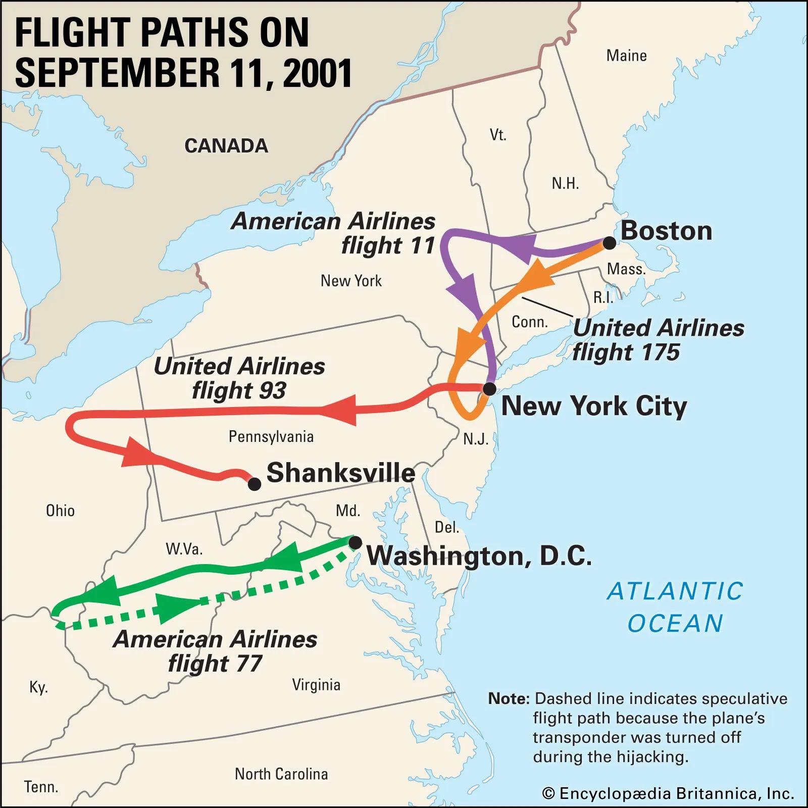](https://www.unz.com/wp-content/uploads/2022/09/DoubleCrossLG-3.jpg)

To recap: **the Pentagon event** was circumscribed to the Washington area, airport included. It was an inside job, requiring only a very small number of people in the know. The purpose was to create a pretext for the invasion of Afghanistan, which had been planned in advance by Pentagon strategists and Deep State operatives. Those who faked the Pentagon attack didn’t bother to provide credible video images of a crash; they were confident that Americans would trust what the authorities would tell them happened, because they knew that the overthrow of the hated Taliban would raise no protest.

In contrast, **the WTC event** was entirely staged, from the takeoff airport to the crash site, under the control of ultra-Zionists financiers and entrepreneurs. It required the cooperation of a vast network of dedicated *sayanim*in very high position, both within and outside the administration. It was aimed at plunging the American people into a rage sufficient to make them support — even demand — total war against any country that **neocons** would designate as harboring **terrorists**. The goal was, as simply stated by Eliot Cohen and Norman Podhoretz, [World War IV](https://www.commentary.org/articles/norman-podhoretz/how-to-win-world-war-iv/), that is, step four toward the making of Greater Israel as imperial power (the biblical project, no less). In the art of manufacturing consent for war, they were in a different league from those who staged the Pentagon attack. With all major corporate medias owned by *sayanim*, they had confidence in their power to create, select and control the images that Americans see, and their ability to put Americans in hypnotic trance by a [“psy-opera”](https://www.youtube.com/watch?v=WCoKYQFruqs) of unprecedented scale.

If our hypothesis is correct, then we should see, right after the 9/11 attacks, a conflict between two groups within the Bush administration: one group of classic Imperial strategists advocating the punitive invasion of Afghanistan and nothing else, and another group dominated by Zionists calling for preemptive wars on Iraq, Iran, Syria, and all regimes unfriendly to Israel. This is precisely what we witnessed. But before looking back at the way the crypto-Zionists managed to get their war on Iraq, a brief presentation of the two competing groups is in order.

[**Anatomy of the Deep State**](read://https_www.unz.com/?url=https%3A%2F%2Fwww.unz.com%2Farticle%2Fthe-9-11-double-cross-conspiracy-theory%2F#anatomy-of-the-deep-state)

What we commonly call the Deep State may have always existed within the United States, but it became a more dominant reality since the National Security Act signed by Truman in 1947, with the creation of the National Security Council, the CIA, and other institutions. Historically, we can say on first approximation that the Deep State is the unelected and semi-secret government of the Empire, under the control of globalist interests. It has its own ideology, which we may call American imperialism, rooted in an old sense of America’s Manifest Destiny.

One of the oldest, most emblematic and most influential institution of this backstage imperialism is **the Council on Foreign Relation**[s].

[For frontstage imperialism see [Anglo-American Establishment](http://chasegalleryconnect.org/FNC_C/Data/People/Individuals/C/Carroll%20Quigley/AAE/) ]

CFR members are internationalists who work through financial and political institutions. They represent the interests of international bankers and investors, who founded the CFR. Although there is no strict uniformity of view among CFR members, it can be said that the CFR is not, historically, pro-Israel. Still today, Israel’s violation of international laws is a subject of criticism in many articles published in the CFR’s magazine, *Foreign Affairs*. Continued friendship with the Saudi dynasty is also, to this day, the preferred policy of the CFR, as illustrated by this very report, [*The Case for a New U.S.-Saudi Strategic Compact*](https://www.amazon.com/Case-New-U-S-Saudi-Strategic-Compact/dp/0876094523/ref=sr_1_4?crid=1XSYTUNTXLIUF&keywords=the+case+for+a+new+compact&qid=1660828854&sprefix=the+case+for+a+new+compac%2Caps%2C283&sr=8-4)*.*

One prominent member of the CFR in the last decades had been Zbigniew Brzezinski. As the title of his best-selling book *The Grand Chessboard*indicates, Brzezinski was a strategist in the old British tradition of the Great Game, which aims at preventing the unification of Eurasia under Russian leadership. As Carter’s National Security Advisor, [Brzezinski instigated the destabilization of the secular and pro-Soviet Afghan regime](https://dgibbs.faculty.arizona.edu/brzezinski_interview) by financing and arming the Mujahideen. In 2001, he had an interest in cleaning up the mess that he had created there. Let us here point out that Brzezinski had, as early as 1997, in reference to the need for public support in imperialistic wars, pointed to the importance of the “shock effect of the Japanese attack on Pearl Harbor” in the past.[[11]“[The American public] supported America’s engagement to World War II largely because of the shock effect of the Japanese attack on Pearl Harbor” (Zbigniew Brzezinski, *The Grand Chessboard,*Basic Books, 1997, p. 24).](read://https_www.unz.com/?url=https%3A%2F%2Fwww.unz.com%2Farticle%2Fthe-9-11-double-cross-conspiracy-theory%2F#footnote_11) That was three years before PNAC expressed the need for “some catastrophic and catalyzing event — like a new Pearl Harbor” in their report *Rebuilding America’s Defenses.*That is a significant detail in support of the hypothesis that PNACers essentially seized and hijacked the Brezinskians’ rhetoric and scheme.

At stake in Afghanistan was the project of an oil pipeline funded by UNOCAL (Union Oil of California). As documented by French experts Jean-Charles Brisard and Guillaume Dasquié in [*Forbidden Truth: U.S.-Taliban Secret Oil Diplomacy and the Failed Hunt for Bin Laden*](https://www.amazon.com/Forbidden-Truth-U-S-Taliban-Secret-Diplomacy/dp/1560254149/ref=sr_1_3?keywords=Jean-Charles+Brisard+Guillaume+Dasqui%C3%A9&qid=1661864123&sr=8-3) (2002), in the early months of 2001, the Bush administration was still negotiating with Kabul, but in July, negotiators lost confidence in the ability of the Taliban to stabilize the country. Their overthrow was planned, together with the pretext for it, including elaborate drawings of [Bin Laden’s cave in Tora Bora](https://www.youtube.com/watch?v=FGhGHxw0mSo).[[12]As drawn by the London *Times*and certified by Donald Rumsfeld, who added on *Meet the Press*(NBC), December 2, 2001, “And there is not one of those, there are many of those.” Watch on YouTube, “Ben Laden’s Cave according to Rumsfeld,” www.youtube.com/watch?v=FGhGHxw0mSo Cave according to Rumsfeld”be, “sky Institute:](read://https_www.unz.com/?url=https%3A%2F%2Fwww.unz.com%2Farticle%2Fthe-9-11-double-cross-conspiracy-theory%2F#footnote_12) The fact that the operation is set in motion less than a month after the 9/11 attacks proves that it was planned in advance (see Nafeez Ahmed, *The War on Freedom,*2001). There were, of course, other criminal elements pushing for the restoration of the Opium trade in Afghanistan, which they got.

[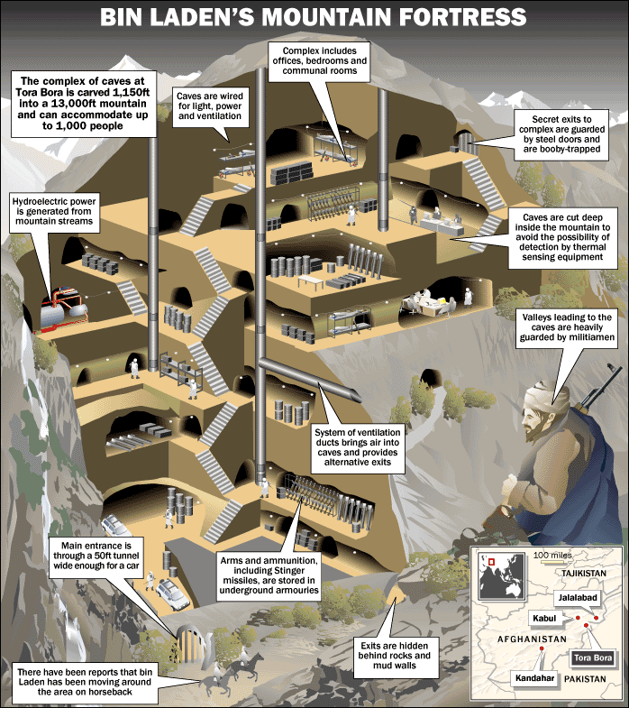](https://www.unz.com/wp-content/uploads/2022/09/DoubleCrossLG-4.gif)

Besides overthrowing the Taliban, American imperialists shared with their Saudi friends an interest in getting rid of Osama bin Laden, whose declared goal was to free Saudi Arabia from American bases and tutelage, and to bring an end to the corrupt Saudi monarchy (as stated in his 1996 *Declaration of War Against the Americans Occupying the Land of the Two Holy Places*). George H.W. Bush, a much [honored CFR director](https://www.cfr.org/search?keyword=George+H.+W.+Bush), was a notorious business friend of the Saudis. As head of the CIA under Ford, he had favored ties with the Saudi dynasty rather than the Mossad, and as president, together with his Secretary of State James Baker, he arm-twisted Israel to the Madrid Conference in November 1991.

Israel is, of course, the great rival of Saudi Arabia for the position of best friend of the U.S. American Zionists have been working hard to undermine U.S.-Saudi ties. Moreover, unlike imperialist Great Gamers like Brzezinski, they were not interested in the conquest of Afghanistan — although they know how to take advantage of any war. What they want is to draw the U.S. into proxy wars against their enemies. Their first priority is [was] the overthrow of Saddam Hussein and the destruction of the Iraqi State.

In order to progressively take control of U.S. foreign and military policy, the neocons pursued two strategies:

1. they sought to gain the high ground and the dominant voice over all American Jewish institutions, with think-tanks like the Jewish Institute for National Security Affairs (JINSA); and
2. they sought to dictate U.S. imperial military strategy, with think-tanks like the Project for a New American Century (PNAC), posturing as believers in America’s world-saving mission.

Although CFR imperialists traditionally favor working through international institutions such as the United Nations, PNAC crypto-Zionists promoted a unilateralist approach, targeting specially Israel’s enemies. Although they failed to force president Bush Senior into taking over Iraq in 1991, they kept pushing for it (David Wurmser, *Tyranny’s Ally: America’s Failure to Defeat Saddam Hussein,*1999).

Progressively, they succeeded in becoming a major force within the Deep State itself, to the point that today, **it could almost be said that Israel is America’s Deep State**. But it was not quite so in the immediate aftermath of 9/11.

[**Two options after 9/11**](read://https_www.unz.com/?url=https%3A%2F%2Fwww.unz.com%2Farticle%2Fthe-9-11-double-cross-conspiracy-theory%2F#two-options-after-9-11)

After 9/11, Colin Powell, a member of the Council on Foreign Relations for thirty-five years (and board member from 2006 to 2016), announced a limited operation in Afghanistan. Brzezinski was in the same line of thinking. So was the Bush clan. But Bush Jr. doesn’t count; he was under the spell of those that his father used to call “the crazies”. While he was reading *My Pet Goat,*his vice-president was running operations from the White House bunker (the PEOC), under the guidance of his crypto-Zionist assistant Lewis “Scooter” Libby.

[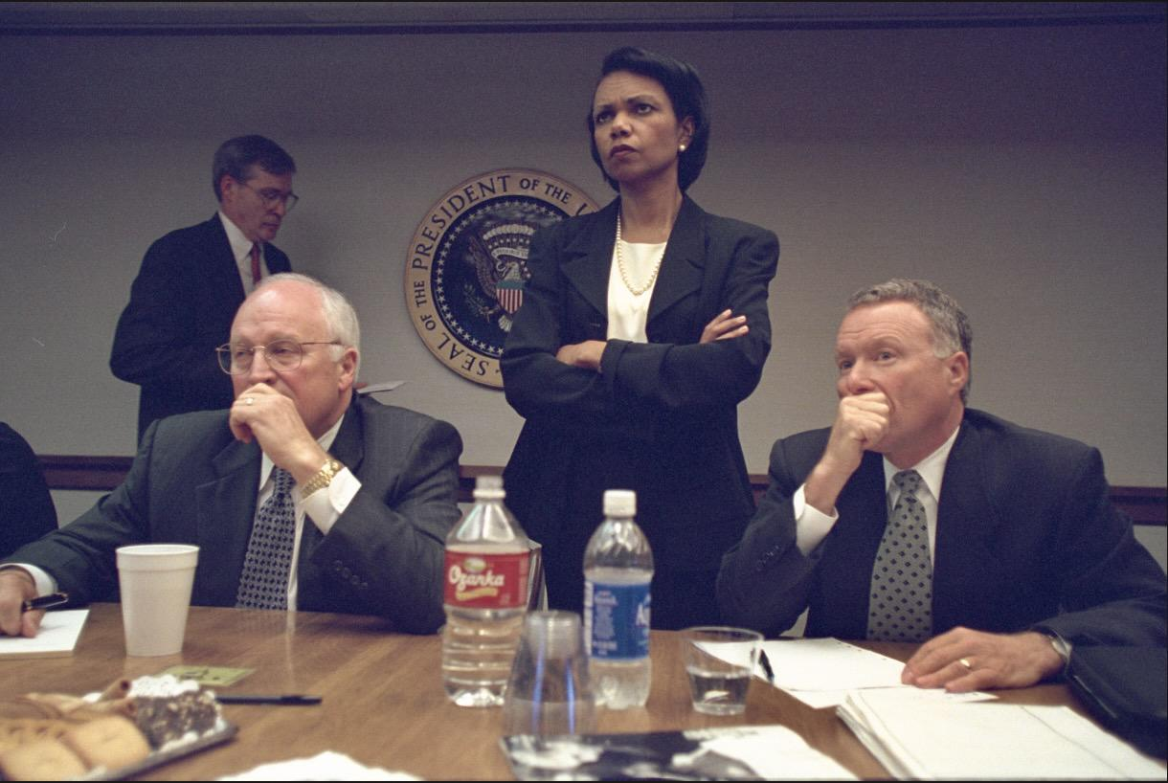](https://www.unz.com/wp-content/uploads/2022/09/DoubleCrossLG-5.jpg)

This is the appropriate place to answer a legitimate objection to the theory of the double-crossed conspiracy: Since the attacks on the Twin Towers preceded the attack on the Pentagon, why didn’t the Pentagon abort its own operation in the meantime? Answer: Because those who had the authority to abort the Pentagon false-flag attack were Cheney and Rumsfeld. Rumsfeld’s whereabouts at the time is unclear — he seems to have made himself unavailable —, but the testimony of the Secretary of Transportation Norman Mineta, who was with Cheney at the PEOC, tends to indicate that Cheney had the authority to abort the operation but refused to do it. [Mineta declared before the 9/11 Commission, on the 23](https://www.youtube.com/watch?v=QlM8Sui6-X0" \o "http://www.youtube.com/watch?v=QlM8Sui6-X0)[rd](https://www.youtube.com/watch?v=QlM8Sui6-X0" \o "http://www.youtube.com/watch?v=QlM8Sui6-X0)[of May, 2003](https://www.youtube.com/watch?v=QlM8Sui6-X0" \o "http://www.youtube.com/watch?v=QlM8Sui6-X0):

*“During the time that the airplane was coming in to the Pentagon, there was a young man who would come in and say to the Vice-President, ‘The plane is 50 miles out.’ ‘The plane is 30 miles out.’ And when it got down to ‘the plane is 10 miles out,’ the young man also said to the Vice-President, ‘Do the orders still stand?’ And the Vice-President turned and whipped his neck around and said, ‘Of course the orders still stand. Have you heard anything to the contrary?’”*[*[13]Griffin, 9/11 Contradictions, op. cit., p. 22-30, filmed on YouTube, “Cheney gave Stand Down Order”: www.youtube.com/watch?v=QlM8Sui6-X0*](read://https_www.unz.com/?url=https%3A%2F%2Fwww.unz.com%2Farticle%2Fthe-9-11-double-cross-conspiracy-theory%2F#footnote_13)

Despite what 9/11 Commission vice chairman Lee Hamilton implies in his questions, Mineta’s answers suggest that Cheney’s order was a stand-down order not to shoot the “plane” coming towards the Pentagon.

Rumsfeld and Cheney have been mercenaries for the Neocons ever since they entered Ford’s administration and introduced Richard Perle’s protégés Paul Wolfowitz and Richard Pipes through the backdoor. This also explains why, a mere five hours after the attacks, Rumsfeld asked his team in the National Military Command Center to provide “all and any information” linking the attacks to Iraq: “Best info fast. Judge whether good enough hit Saddam Hussein at same time. Not only UBL [Usama bin Laden]. Go massive. Sweep it all up. Things related and not” (according to notes obtained by David Martin, correspondent on the National Security Council for CBS News).[[14]Julian Borger, “Blogger bares Rumsfeld’s post 9/11 orders”, *The Gardian,*February 24, 2006, www.guardian.co.uk/world/2006/feb/24/freedomofinformation.september11](read://https_www.unz.com/?url=https%3A%2F%2Fwww.unz.com%2Farticle%2Fthe-9-11-double-cross-conspiracy-theory%2F#footnote_14)

On September 19th and 20th, Richard Perle’s Defense Policy Board met with Paul Wolfowitz and Bernard Lewis,[[15]Bernard Lewis, *What Went Wrong? The Clash between Islam and Modernity in the Middle East,*Harper Perennial, 2003.](read://https_www.unz.com/?url=https%3A%2F%2Fwww.unz.com%2Farticle%2Fthe-9-11-double-cross-conspiracy-theory%2F#footnote_15) but without Colin Powell and Condoleezza Rice. They prepared a letter to the President, in PNAC letterhead, to remind him of his historic mission: “even if evidence does not link Iraq directly to the attack, any strategy aiming at the eradication of terrorism and its sponsors must include a determined effort to remove Saddam Hussein from power in Iraq. Failure to undertake such an effort will constitute an early and perhaps decisive surrender in the war on international terrorism.”[[16]Stephen Sniegoski, *The Transparent Cabal: The Neoconservative Agenda, War in the Middle East, and the National Interest of Israel,*Enigma Edition, 2008, p. 144.](read://https_www.unz.com/?url=https%3A%2F%2Fwww.unz.com%2Farticle%2Fthe-9-11-double-cross-conspiracy-theory%2F#footnote_16) Perle would continue to claim against all evidence that Mohamed Atta, the alleged ringleader of the 9/11 terrorists, “met Saddam Hussein in Baghdad prior to September 11. We have proofs of that.”[[17]Gary Leupp, “Richard Perle’s Bombshell in Milan”, *Conterpunch,*September 10, 2002, www.counterpunch.org/2002/09/10/richard-perle-s-bombshell-in-milan/](read://https_www.unz.com/?url=https%3A%2F%2Fwww.unz.com%2Farticle%2Fthe-9-11-double-cross-conspiracy-theory%2F#footnote_17)

The rumors of a link between Saddam and Al-Qaeda were finally abandoned in favor of the no less fictional threat posed by Saddam’s “weapons of mass destruction,” with an emphasis on biological weapons. Just a week after September 11, Richard Perle [told *CNN*](https://www.youtube.com/watch?v=0PqU7dXEirU&t=49s) that the next terror attack is likely to involve “chemical or biological weapons.” And it did: on September 18th and October 9th, four letters contaminated with anthrax were mailed to journalists and senators (curiously, two senators opposed to the USA PATRIOT Act, Tom Daschle and Patrick Leahy), causing 22 deaths. The letters were written in such a way as to clearly identify the author as fanatic Muslim: “You can not stop us. We have this anthrax. You die now. Are you afraid? Death to America. Death to Israel. Allah is great.”

Prior to the sending of the letters, the FBI received an anonymous letter accusing Professor Ayaad Assaad, an American of Egyptian origin, of being a bio-terrorist. It was determined that the strains of anthrax came from the military laboratory in Utah where Assaad worked. The FBI found Assad innocent. It was later revealed in the *Hartford Courant* that in 1992 surveillance cameras had captured Lieutenant Colonel Philip Zack entering the laboratory’s storage location illegally, and that, in the same period, pathogens had disappeared from the center. Zack had been discharged from the laboratory after a complaint by Assad for receiving a racist letter co-signed by Zack.[[18]Lynne Tuohy and Jack Dolan, “Turmoil in a Perilous Place”, December 19, 2001, s3.amazonaws.com/911timeline/2001/hartfordcourant121901.html, and “Anthrax Missing From Army Lab,” January 20, 2002, www.ph.ucla.edu/EPI/bioter/anthraxmissingarmylab.html](read://https_www.unz.com/?url=https%3A%2F%2Fwww.unz.com%2Farticle%2Fthe-9-11-double-cross-conspiracy-theory%2F#footnote_18) The FBI paid no attention to this revelation, having probably been warned by their boss Michael Chertoff to leave the *sayanim*alone.

[The anthrax attacks](https://www.amazon.com/2001-Anthrax-Deception-Domestic-Conspiracy/dp/0986073121/ref=sr_1_1?crid=25TJIPI0GCWSI&keywords=Anthrax+MacQueen&qid=1662040133&s=digital-text&sprefix=anthrax+macqueen%2Cdigital-text%2C131&sr=1-1-catcorr) came handy to give credibility to the threat of Saddam’s WMD. Cheney and Rumsfeld circumvented CIA director George Tenet, who knew that Saddam was no longer in possession of such weapons, and renewed their winning “Team B” strategy from the 70s, essentially overtaking the CIA with a parallel structure set up to produce the alarmist report they needed: the Office of Special Plans (OSP). Nicknamed “the Cabal,” the OSP was controlled by neocons William Luti, Abram Shulsky, Douglas Feith and Paul Wolfowitz.

In September 2002, dummy Bush Jr. signed the *National Security Strategy report*(*NSS* 2002), which defined what would be called the “Bush doctrine” — despite being an update to the 1992 “Wolfowitz doctrine” of preemptive wars. On October 7, he read on his teleprompter that, “Saddam Hussein is a homicidal dictator who is addicted to weapons of mass destruction,” who could at any time “provide a biological or chemical weapon to a terrorist group or individual terrorists.”[[19]www.presidentialrhetoric.com/speeches/10.7.02.html, Sniegoski, *Transparent Cabal*, *op. cit.,*p. 155.](read://https_www.unz.com/?url=https%3A%2F%2Fwww.unz.com%2Farticle%2Fthe-9-11-double-cross-conspiracy-theory%2F#footnote_19)

Colin Powell found himself pressured by those he called the “separate little government” composed of “Wolfowitz, Libby, Feith, and Feith’s ‘Gestapo Office’.”[[20]According to his biographer Karen DeYoung, as quoted by Sniegoski, *Transparent Cabal*, *op. cit.,*p. 183.](read://https_www.unz.com/?url=https%3A%2F%2Fwww.unz.com%2Farticle%2Fthe-9-11-double-cross-conspiracy-theory%2F#footnote_20) On February 5, 2003, he declared to the General Assembly of the United Nations, “there can be no doubt that Saddam Hussein has biological weapons and the capability to rapidly produce more, many more. And he has the ability to dispense these lethal poisons and diseases in ways that can cause massive death and destruction.”[[21]Sniegoski, *Transparent Cabal*, *op. cit.,*p. 183.](read://https_www.unz.com/?url=https%3A%2F%2Fwww.unz.com%2Farticle%2Fthe-9-11-double-cross-conspiracy-theory%2F#footnote_21) After leaving his post in 2004, he called this speech “a blot on my record,” adding, “and there is nothing I can do to change that blot.”[[22]Steven Weisman, “Powell Calls His U.N. Speech a Lasting Blot on His Record”, *New York Times,*September 9, 2005, www.nytimes.com/2005/09/09/politics/09powell.html](read://https_www.unz.com/?url=https%3A%2F%2Fwww.unz.com%2Farticle%2Fthe-9-11-double-cross-conspiracy-theory%2F#footnote_22) I find these words revealing. We would expect him to think first of the unspeakable suffering inflicted on the Iraqi people because of him, but what is on his mind is “a blot on his record,” and the possibility of editing it out. Such a man is easy to buy or blackmail. His “record” (in Vietnam) is in the hands of Jewish medias anyway, who, from one day to the next, can turn his public image from war hero to war criminal.

It is no longer a matter of debate that the Iraq war was primarily an Israeli job (John Mearsheimer and Stephen Walt, *The Israel Lobby and U.S. Foreign Policy,*2007). **The CFR** (which I mention here as representative of the American imperialist school) **remained overwhelmingly critical of the Iraq war**, wishing that the Neocons’ ideas [“lie buried in the sand of Iraq”](https://www.cfr.org/blog/neocons-and-zombies) forever. **But they had lost control of American foreign policy, and have not regained it since.** As for **Brzezinski**, he **denounced** before the Senate **“a historical, strategic and moral calamity … driven by Manichean impulses and imperial hubris”** (February 2007).  
  
[Subscribe to New Columns](https://www.unz.com/subscribe/?domain=article)

Nowhere is the divergence of goals between   
-- the CFR Imperialists and   
-- the PNAC crypto-Zionists   
more evident than in **their approach to Saudi Arabia, America’s strategic ally in the Middle East since Roosevelt’s Quincy Pact.**

[Following paragraphs address  
 -- the PNAC crypto-Zionists ]

Weeks after the attacks of September 11th, David Wurmser both a PNAC member and a co-author of the 1996 *Clean Break*report to Netanyahu, opened the hostilities in the *Weekly Standard* with an article titled “The Saudi Connection,” claiming that the royal family was behind the attack.[[23]“The Saudi Connection: Osama bin Laden’s a lot closer to the Saudi royal family than you think,”  
  
*The Weekly Standard,*October 29, 2001. This article is now unavailable on the Internet but is mentioned here: https://www.washingtonexaminer.com/weekly-standard/t...5045#!](read://https_www.unz.com/?url=https%3A%2F%2Fwww.unz.com%2Farticle%2Fthe-9-11-double-cross-conspiracy-theory%2F#footnote_23) Then in December 2002 news outlet started mentioning the 28 redacted pages of the “Joint Inquiry into Intelligence Community Activities before and after the Terrorist Attacks of September 11, 2001” conducted by the Senate and House Select Committees on Intelligence. These pages, finally disclosed in 2016, pretended to show that some of the hijackers, 15 of them Saudi citizens, received financial and logistical support from individuals linked to the Saudi government. Needless to say, since no Saudi hijacked any plane on 9/11, this report is as bogus as the whole 9/11 Commission report. But on that fabricated basis, Richard Perle and David Frum argued in their book *An End to Evil: How to Win the War on Terror*(2003), that “the Saudis qualify for their own membership in the axis of evil,” and implore President Bush to “tell the truth about Saudi Arabia,” namely that the Saudi princes finance Al-Qaeda.[[24]Sniegoski, *Transparent Cabal*, *op. cit.,* p. 204.](read://https_www.unz.com/?url=https%3A%2F%2Fwww.unz.com%2Farticle%2Fthe-9-11-double-cross-conspiracy-theory%2F#footnote_24) Senator Bob Graham was the most active on mainstream channels accusing Bush to have covered the Saudi involvement in 9/11 because of “the special personal friendship between the [Saudi] royal family and the highest levels of our national government [meaning the President].”[[25]Bob Graham, *Intelligence Matters: The CIA, the FBI, Saudi Arabia, and the Failure of America’s War on Terror,*Random House, 2004; “Saudi Arabia: Friend or Foe?” *The Daily Beast,*July 11, 2011, www.thedailybeast.com/articles/2011/07/11/saudi-arabia-fried-or-foe-asks-senator-bob-graham.html](read://https_www.unz.com/?url=https%3A%2F%2Fwww.unz.com%2Farticle%2Fthe-9-11-double-cross-conspiracy-theory%2F#footnote_25) Along this line of argument, you now have books like [*The Stealth Saudi Arabian Takeover of America*](https://www.amazon.com/Stealth-Saudi-Arabian-Takeover-America-ebook/dp/B07TZNF7K5/ref=sr_1_fkmr0_1?crid=1NK573WKYPFPW&keywords=George+Walters%2C+The+Stealth+Saudi+Arabian+Takeover+of+America%2C+Independantly+Published%2C+2019&qid=1662309475&s=books&sprefix=george+walters%2C+the+stealth+saudi+arabian+takeover+of+america%2C+independantly+published%2C+2019%2Cstripbooks-intl-ship%2C127&sr=1-1-fkmr0).

[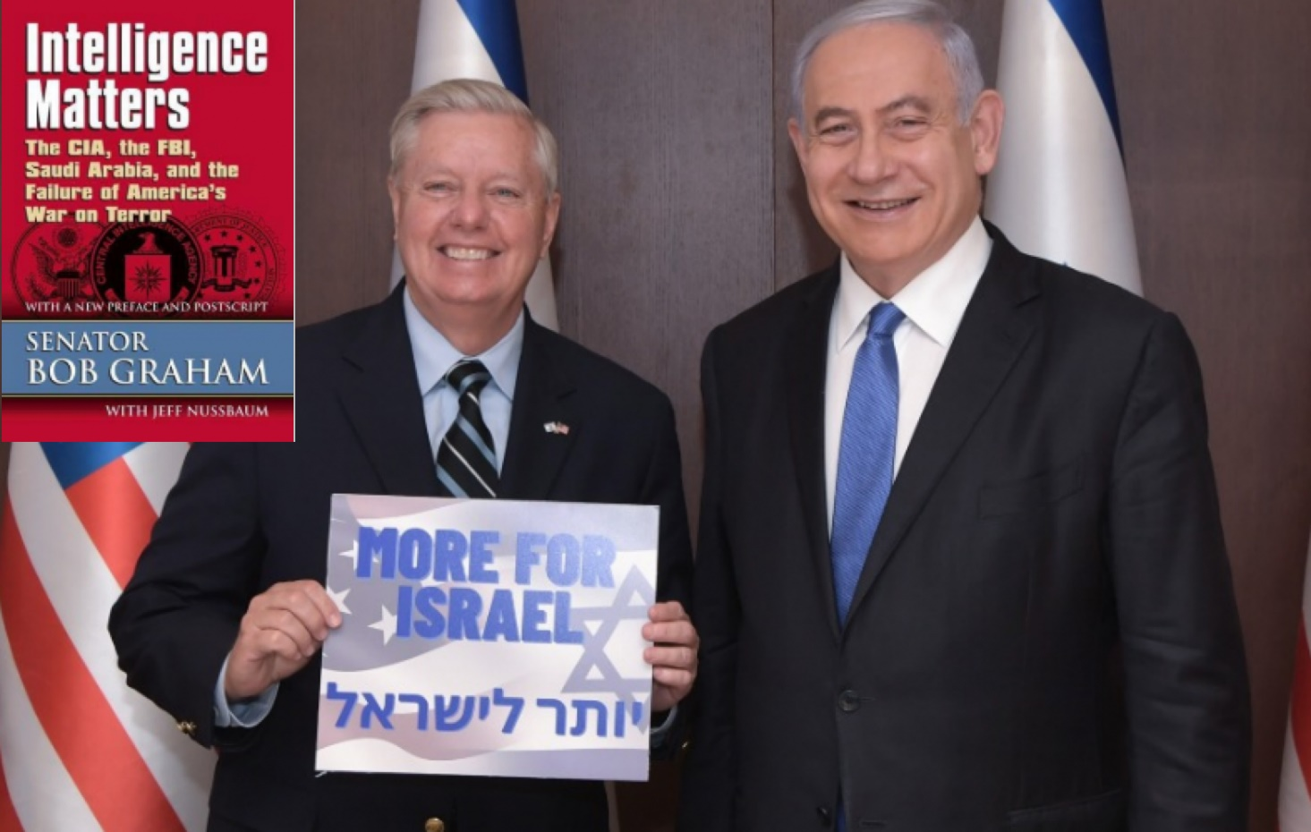](https://www.unz.com/wp-content/uploads/2022/09/DoubleCrossLG-6.png)

[**Conclusion: the collapse of the twin lies**](read://https_www.unz.com/?url=https%3A%2F%2Fwww.unz.com%2Farticle%2Fthe-9-11-double-cross-conspiracy-theory%2F#conclusion-the-collapse-of-the-twin-lies)

My model is too simple, I know. In reality, the dividing line between Imperialists and Zionists is blurry. Take **Henry Kissinger**, for example, a pillar of the CFR since 1956, who served as a member of its Board of Directors from 1977 to 1981. It is hard to distinguish in him the Imperialist and the Zionist. But the fact is that, until the 1970s, most American Big Jews like him were not unconditionally supportive of Israel. Their conversion began in 1967, on the condition that Israeli leaders recognize their crucial role and stop catechizing them into emigrating. On this new understanding of “what is good for the Jews”, Israel and the Diaspora reunited like a school of fish, giving birth to what J.J. Goldberg called “the new Jews” in America (*Jewish Power,*1997). It is the mission of the [Israeli Ministry of Diaspora Affairs](https://www.gov.il/en/departments/ministry_of_diaspora/govil-landing-page) to maintain this covenant — **and Israel’s pool of *sayanim****.*

[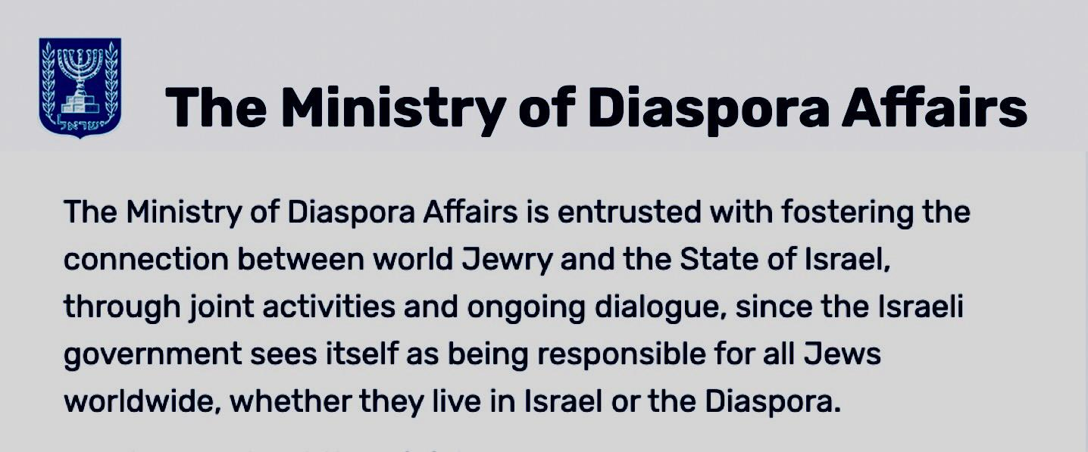](https://www.unz.com/wp-content/uploads/2022/09/DoubleCrossLG-7.jpg)

Kissinger, like so many others, followed the trend, and after 9/11 aligned himself with the neocons, as did his protégé L. Paul Bremer. On February 13, 2002, Kissinger suggested that, after the success of their mission in Afghanistan, the U.S. should keep the momentum by invading Iraq [(“because Afghanistan was not enough,”](https://www.humiliationstudies.org/documents/DannerHenryKissinger.pdf) he later explained).

My attempt to distinguish between two operations within 9/11 may also be simplistic, especially since the Pentagon was heavily infiltrated by the most ardent **secret Zionists**. Yet I think it has its value as a working hypothesis, at least in bridging the gap between the “inside-jobbers” and the “Israeli-jobbers” among 9/11 truthers. The Pentagon attack appears to have been planned in Washington, while the WTC attacks were planned in Tel Aviv and New York. The Pentagon fakery was an inside job, but the Twin Towers [“psy-opera”](https://www.youtube.com/watch?v=WCoKYQFruqs) was an Israeli job. Since the attack on the Twin Towers came to define 9/11 in public consciousness, we can say that Israel did 9/11, but we must keep in mind that they could only do it with impunity by plugging into a Pentagon operation of smaller scope. The U.S. National Security State did part of 9/11, but that was the smallest part — just big enough for being blackmailed into submission to Israel’s agenda.

That is why “9/11 was an inside job” is not just a half-truth; it is a lie by omission. 9/11 truthers who keep chanting this mantra and bringing up Operation Northwood instead of the USS Liberty, are fundamentally misleading Americans and providing cover for the real rogue State of the Middle East. I am not including in this critic 9/11 engineers, architects, pilots and so on who expose the technical impossibilities of the official conspiracy theory and demand a new investigation, without claiming to know who did 9/11. I am talking of those who point the finger exclusively to the Bush administration, without even hinting at the Neocons’ foreign loyalty. I can understand the logic of feeding Americans the truth one bit at a time, but what is the point of serving them the same overchewed bit for 21 years? Why continue to focus on the “inside job” angle, when the larger picture makes so much more sense?

Now, it is good strategy for enemy countries of the American NATO Empire to start calling 9/11 an “inside job” in their information warfare, as Russia, China, Iran and others will increasingly do. A year ago, for example, Russia’s state-owned news agency RIA Novosti published a 9/11 analysis by its star journalist Viktoria Nikiforova, titled [“The U.S. refuses to reveal the secret of 9/11”](https://ria.ru/20210909/godovschina-1749237778.html) (translation [here](https://thefrontierpost.com/us-refuses-to-reveal-9-11-mystery/)) and including the following: “Experts at the University of Alaska at Fairbanks calculated that the fire could not have led to the collapse of the third skyscraper, which is surprisingly rarely mentioned by the mainstream media.” We can expect more of the same this month. **But Americans are in a totally different position: if they care for their future, they have to start naming their real enemy. Naming the Neocons for what they really are is a good start.** When speaking to Jewish audiences, their mentor Leo Strauss expressed no concern for the U.S. other than what it can do to further the Jews’ global destiny, for, he said, “since a very, very early time the main theme of my reflections has been what is called the ‘Jewish question’” (see my article [“9/11 was a Straussian Coup”](https://www.unz.com/article/9-11-was-a-straussian-coup/)). Strauss did not intend this lecture to be published, but it is. Why then do most 9/11 truthers continue to rely on books with titles such as [*Leo Strauss and the Politics of American Empire*](https://www.amazon.com/Leo-Strauss-Politics-American-Empire/dp/0300104367/ref=sr_1_1?crid=Z3JZ7CTEV2II&keywords=Leo+strauss+and+the+politics+of+american&qid=1662277984&sprefix=leo+strauss+and+the+politics+of+american%2Caps%2C140&sr=8-1), or [*Leo Strauss and the American Right*](https://www.amazon.com/Strauss-American-Right-Shadia-Drury/dp/0312217838/ref=sr_1_3?crid=Z3JZ7CTEV2II&keywords=Leo+strauss+and+the+politics+of+american&qid=1662277998&sprefix=leo+strauss+and+the+politics+of+american%2Caps%2C140&sr=8-3)*,*or [*Leo Strauss and Anglo-American Democracy*](https://www.amazon.com/Leo-Strauss-Anglo-American-Democracy-Conservative-ebook/dp/B07X1MZLMT/ref=sr_1_2?crid=Z3JZ7CTEV2II&keywords=Leo+strauss+and+the+politics+of+american&qid=1662277998&sprefix=leo+strauss+and+the+politics+of+american%2Caps%2C140&sr=8-2)? **Let us say it again and again: the Straussian Neocons are crypto-Zionist traitors who did 9/11 to drag America into proxy wars for Israel.**

Let’s be honest: those who refuse to discuss, or even think about Israel’s involvement in 9/11, do it for the same reason that most people refrain from blaming Israel, no matter how many crimes Israel commits. Some things haven’t changed for two thousand years: “no one spoke about him openly, for fear of the Jews” (Gospel of John 7:13). Fear of the Jews is legitimate, but should not be confused with love of the truth. Fear of the Jews, remember, is the happy ending of the Book of Esther, after the Jews of Persia preemptively slaughtered their enemies (under the [“rise and kill first”](https://www.amazon.com/Rise-Kill-First-Targeted-Assassinations-ebook/dp/B01N7LQ2NR/ref=sr_1_1?crid=2AIDC750LEHB8&keywords=rise+and+kill+first&qid=1662040185&s=digital-text&sprefix=rise+and+kill+first%2Cdigital-text%2C151&sr=1-1) principle): “there was joy and gladness among the Jews, with feasting and holiday-making. Of the country’s population many became Jews, since now the Jews were feared” (8:17). Every year [Jews celebrate this joyful bloodbath by the feast of Purim](https://www.amazon.com/Reckless-Rites-Violence-Christians-Muslims-ebook/dp/B07DSLT8VG/ref=sr_1_1?crid=2SXZ506XEUIU2&keywords=Reckless+rites&qid=1662040231&s=digital-text&sprefix=reckless+rites%2Cdigital-text%2C145&sr=1-1). And as [Kevin Barrett has noted](https://www.lipstickalley.com/threads/presstv-israel-celebrates-successful-9-11-operation-on-purim-holiday.1097302/), “Purim exalts and commemorates an ancient operation very much like 9/11. It glorifies the deceptions of Esther, who concealed her Jewish identity to seduce the King of Persia, then slyly tricked him into slaughtering 75,000 people deemed ‘enemies of the Jews.’” **That is the deeper truth of 9/11: like**[**Zionism itself**](https://www.amazon.com/Yahweh-Zion-Jealous-Promised-Civilizations/dp/0996143041/ref=sr_1_3?dchild=1&keywords=Laurent+Guyenot&qid=1628536961&s=books&sr=1-3)**, 9/11 is biblical.**

I will leave the last word to the first 9/11 Truther:[[26]Interview with the Pakistani newspaper *Daily Ummat*, translated by BBC World Monitoring Service, on www.globalresearch.ca/interview-with-osama-bin-laden-denies-his-involvement-in-9-11/24697 ; also in Webster Griffin Tarpley, *9/11 Synthetic Terror Made in USA,*Progressive Press, 2008, p. 136-8.](read://https_www.unz.com/?url=https%3A%2F%2Fwww.unz.com%2Farticle%2Fthe-9-11-double-cross-conspiracy-theory%2F#footnote_26)

[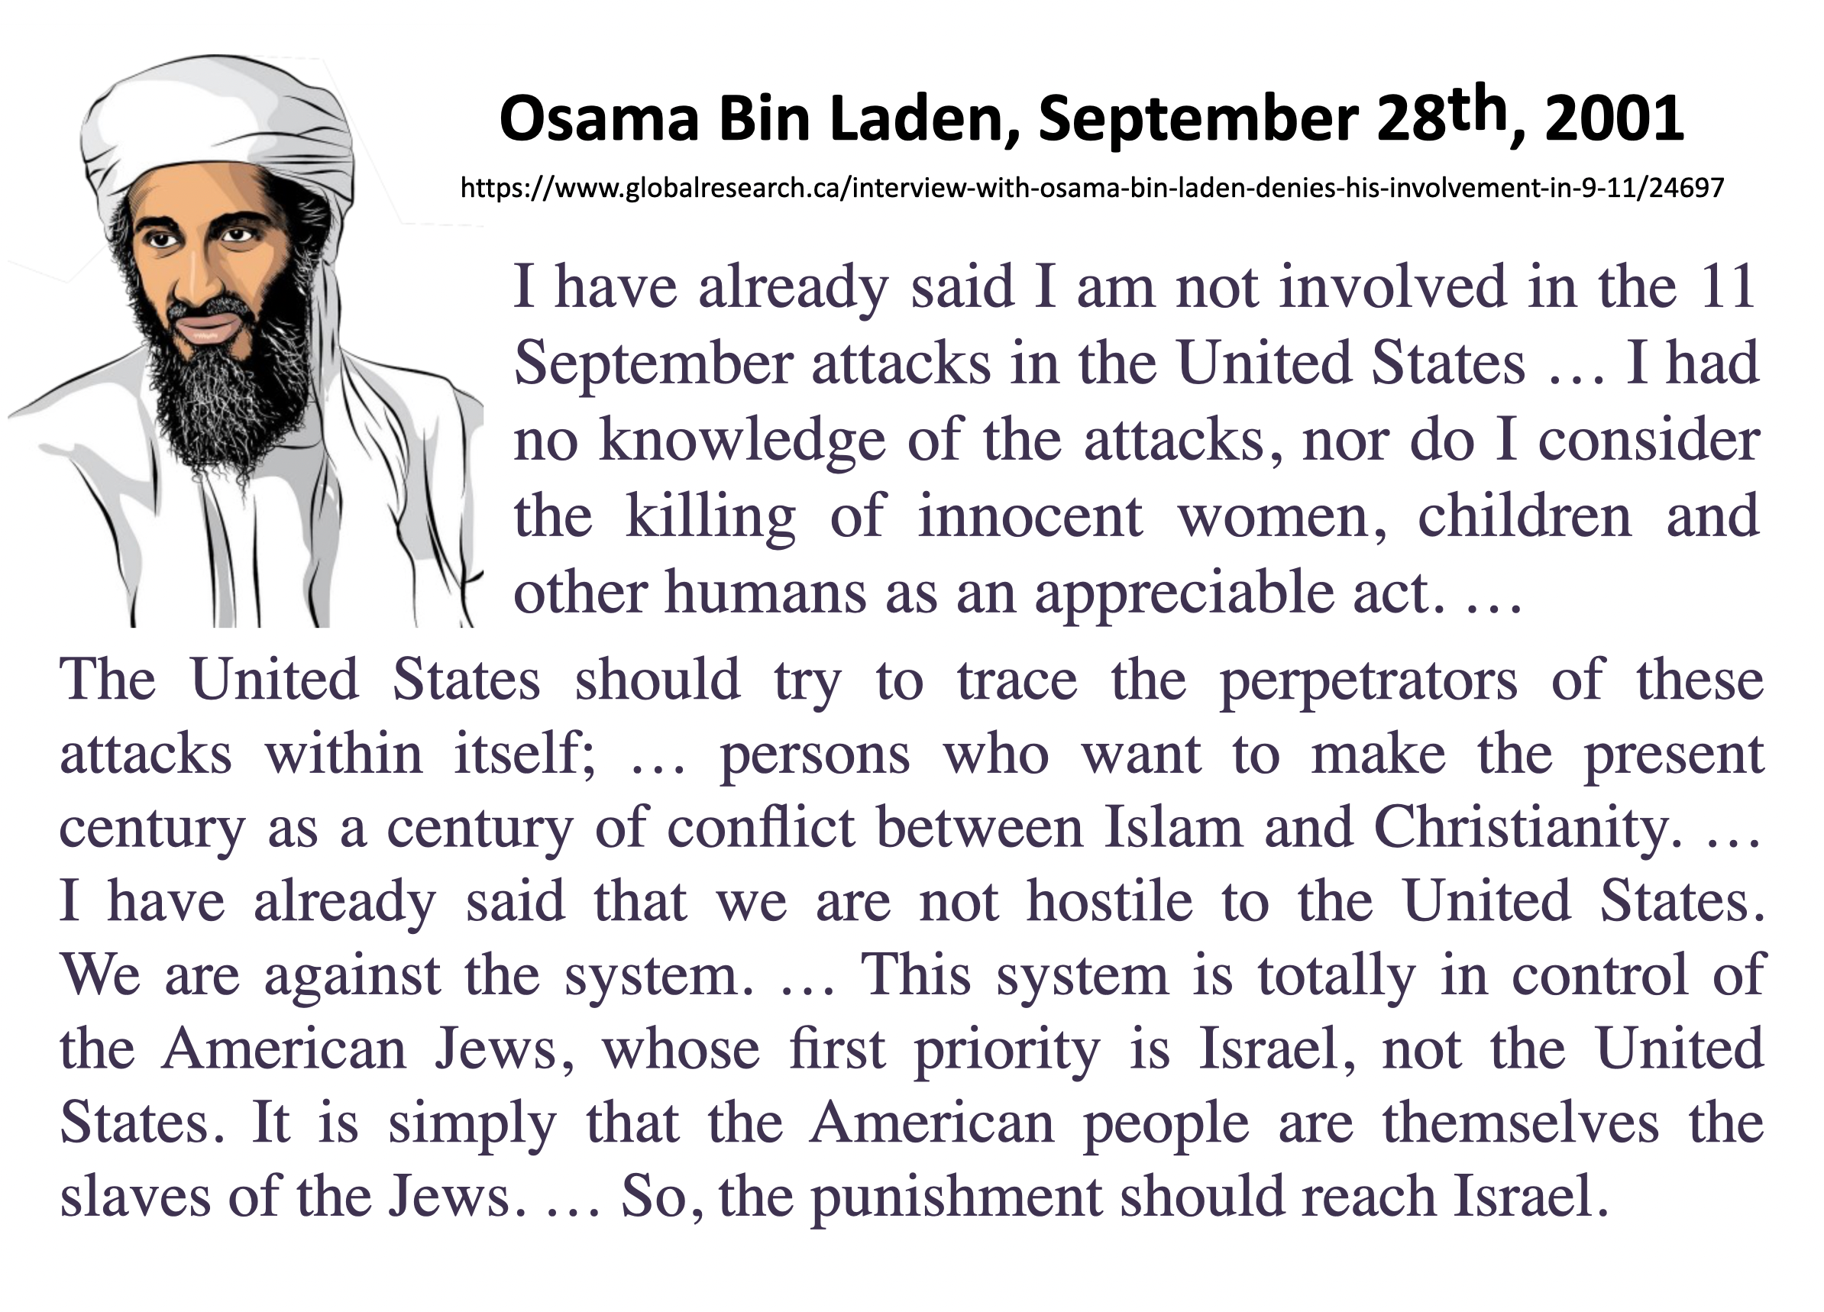](https://www.unz.com/wp-content/uploads/2022/09/DoubleCrossLG-8.png)

**[** [I have already said that I am not involved in the 11 September attacks in the United States. As a Muslim, I try my best to avoid telling a lie. I had no knowledge of these attacks, nor do I consider the killing of innocent women, children, and other humans as an appreciable act. Islam strictly forbids causing harm to innocent women, children, and other people.](http://chasegalleryconnect.org/FNC_C/Data/Our%20World/Conspiracy%20Theories/Sept_11%209-11%20%20theories/Osama%20BinLaden/BinLaden%20-%20NOT%209-11%20++++.html) **]**

[**Addendum**](read://https_www.unz.com/?url=https%3A%2F%2Fwww.unz.com%2Farticle%2Fthe-9-11-double-cross-conspiracy-theory%2F#addendum)

Here is an additional piece of evidence of the double-cross scenario. In the summer of 2001, the Drug Enforcement Agency issued a report that was revealed to the public by *Intelligence Online*magazine in March 2002. According to this report, 140 Israeli spies, aged 20 to 30, had been arrested between March 2001 and September 11th. According to the D.E.A. report, “the Hollywood, Florida area seems to be a central point for these individuals.” More than 30 of the 140 Israeli spies identified prior to 9/11 resided in or near Hollywood, Florida. By an incredible coincidence, this geographic area is also where 14 of the 19 alleged Islamist hijackers had congregated. This was first pointed out by Justin Raimondo in *The Terror Enigma: 9/11 and the Israeli Connection*(iUniversal, 2003, p. 3). The names of the hijackers and their residence at the time can be checked on this FBI page: <https://archives.fbi.gov/archives/news/pressrel/press-releases/fbi-announces-list-of-19-hijackers>

Now here is an even more astonishing coincidence: it turns out that the only hijackers who were not part of those residing close to the Israeli spy ring were those of AA77, the Pentagon plane. That is as clear an indication as we can get that the complete list of hijackers had two different origins: the identities of the 14 “hijackers” of AA11, UA175, and UA93 were gathered in advance by Israelis living in the Hollywood, Florida, area. They were added to the list already prepared by the Pentagon plotters, that included only the 5 hijackers of AA77.

[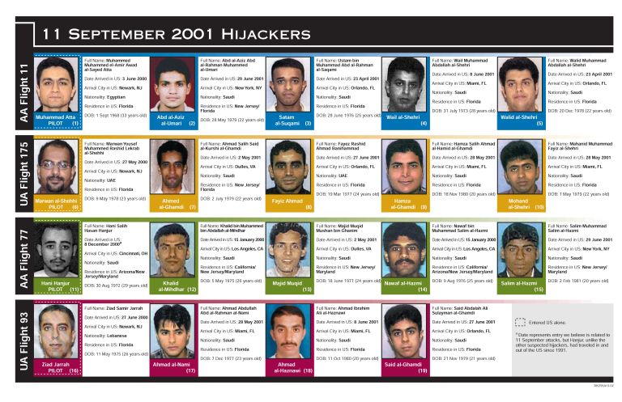](https://www.unz.com/wp-content/uploads/2022/09/DoubleCrossLG-9.png)

**Notes**

[[1]](read://https_www.unz.com/?url=https%3A%2F%2Fwww.unz.com%2Farticle%2Fthe-9-11-double-cross-conspiracy-theory%2F#footnoteref_1) Rowan Scarborough, “U.S. troops would enforce peace Under Army study”, *The Washington Times,*Sept 10, 2001, [www.washingtontimes.com/news/2001/sep/10/20010910-025319-6906r/](https://www.washingtontimes.com/news/2001/sep/10/20010910-025319-6906r/)

[[2]](read://https_www.unz.com/?url=https%3A%2F%2Fwww.unz.com%2Farticle%2Fthe-9-11-double-cross-conspiracy-theory%2F#footnoteref_2) Michael Collins Piper, *False Flag: Template for Terror,*American Free Press, 2013, pp. 86-87.

[[3]](read://https_www.unz.com/?url=https%3A%2F%2Fwww.unz.com%2Farticle%2Fthe-9-11-double-cross-conspiracy-theory%2F#footnoteref_3) Michael Collins Piper, *False Flag, op. cit.,*p. 17.

[[4]](read://https_www.unz.com/?url=https%3A%2F%2Fwww.unz.com%2Farticle%2Fthe-9-11-double-cross-conspiracy-theory%2F#footnoteref_4) David Shipler, “Terrorist Plots, Hatched by the F.B.I.”, *New York Times, Sunday Review*, April 28, 2012, [www.nytimes.com/2012/04/29/opinion/sunday/terrorist-plots-helped-along-by-the-fbi.html?\_r=2&.](https://www.nytimes.com/2012/04/29/opinion/sunday/terrorist-plots-helped-along-by-the-fbi.html?_r=2&.) See also Abby Goodnough, “Man is Held in a Plan to Bomb Washington”, *New York Times,*September 28, 2001, [www.nytimes.com/2011/09/29/us/massachusetts-man-accused-of-plotting-to-bomb-washington.html?\_r=1&pagewanted=all](https://www.nytimes.com/2011/09/29/us/massachusetts-man-accused-of-plotting-to-bomb-washington.html?_r=1&pagewanted=all)

[[5]](read://https_www.unz.com/?url=https%3A%2F%2Fwww.unz.com%2Farticle%2Fthe-9-11-double-cross-conspiracy-theory%2F#footnoteref_5) [www.lefigaro.fr/flash-actu/2012/03/30/97001-20120330FILWWW00344-toulouse-la-france-traumatisee-sarkozy.php](http://www.lefigaro.fr/flash-actu/2012/03/30/97001-20120330FILWWW00344-toulouse-la-france-traumatisee-sarkozy.php)

[[6]](read://https_www.unz.com/?url=https%3A%2F%2Fwww.unz.com%2Farticle%2Fthe-9-11-double-cross-conspiracy-theory%2F#footnoteref_6) Nick Kollerstrom, *Who did 9/11,*New Alchemy Press, 2021, p. 2.

[[7]](read://https_www.unz.com/?url=https%3A%2F%2Fwww.unz.com%2Farticle%2Fthe-9-11-double-cross-conspiracy-theory%2F#footnoteref_7) Sara Leibovich-Dar, “Up in Smoke,” *Haaretz*, November 21, 2001, [www.haaretz.com/2001-11-21/ty-article/up-in-smoke/0000017f-dc11-d856-a37f-fdd16fb20000](http://www.haaretz.com/2001-11-21/ty-article/up-in-smoke/0000017f-dc11-d856-a37f-fdd16fb20000)

[[8]](read://https_www.unz.com/?url=https%3A%2F%2Fwww.unz.com%2Farticle%2Fthe-9-11-double-cross-conspiracy-theory%2F#footnoteref_8) Transcript on transcripts.cnn.com/show/gb/date/2006-11-23/segment/01

[[9]](read://https_www.unz.com/?url=https%3A%2F%2Fwww.unz.com%2Farticle%2Fthe-9-11-double-cross-conspiracy-theory%2F#footnoteref_9) Stephanie Armour, “Firms realize workplaces will never be the same”, *USA Today*, September 17, 2001, usatoday30.usatoday.com/money/general/2001-09-17-workplace-changes.htm

[[10]](read://https_www.unz.com/?url=https%3A%2F%2Fwww.unz.com%2Farticle%2Fthe-9-11-double-cross-conspiracy-theory%2F#footnoteref_10) The link between UA93 and Israel would include evidence suggesting that alleged pilot hijacker Ziad Jarrah was a Deep Cover Operative for Israel, as explained here: israeli-connections-to-911.com/2015/09/06/part-3-8/

[[11]](read://https_www.unz.com/?url=https%3A%2F%2Fwww.unz.com%2Farticle%2Fthe-9-11-double-cross-conspiracy-theory%2F#footnoteref_11) “[The American public] supported America’s engagement to World War II largely because of the shock effect of the Japanese attack on Pearl Harbor” (Zbigniew Brzezinski, *The Grand Chessboard,*Basic Books, 1997, p. 24).

[[12]](read://https_www.unz.com/?url=https%3A%2F%2Fwww.unz.com%2Farticle%2Fthe-9-11-double-cross-conspiracy-theory%2F#footnoteref_12) As drawn by the London *Times*and certified by Donald Rumsfeld, who added on *Meet the Press*(NBC), December 2, 2001, “And there is not one of those, there are many of those.” Watch on YouTube, “Ben Laden’s Cave according to Rumsfeld,” [www.youtube.com/watch?v=FGhGHxw0mSo](https://www.youtube.com/watch?v=FGhGHxw0mSo) Cave according to Rumsfeld”be, “sky Institute:

[[13]](read://https_www.unz.com/?url=https%3A%2F%2Fwww.unz.com%2Farticle%2Fthe-9-11-double-cross-conspiracy-theory%2F#footnoteref_13) Griffin, *9/11 Contradictions, op. cit.,*p. 22-30, filmed on YouTube, “Cheney gave Stand Down Order”: [www.youtube.com/watch?v=QlM8Sui6-X0](https://www.youtube.com/watch?v=QlM8Sui6-X0)

[[14]](read://https_www.unz.com/?url=https%3A%2F%2Fwww.unz.com%2Farticle%2Fthe-9-11-double-cross-conspiracy-theory%2F#footnoteref_14) Julian Borger, “Blogger bares Rumsfeld’s post 9/11 orders”, *The Gardian,*February 24, 2006, [www.guardian.co.uk/world/2006/feb/24/freedomofinformation.september11](http://www.guardian.co.uk/world/2006/feb/24/freedomofinformation.september11)

[[15]](read://https_www.unz.com/?url=https%3A%2F%2Fwww.unz.com%2Farticle%2Fthe-9-11-double-cross-conspiracy-theory%2F#footnoteref_15) Bernard Lewis, *What Went Wrong? The Clash between Islam and Modernity in the Middle East,*Harper Perennial, 2003.

[[16]](read://https_www.unz.com/?url=https%3A%2F%2Fwww.unz.com%2Farticle%2Fthe-9-11-double-cross-conspiracy-theory%2F#footnoteref_16) Stephen Sniegoski, *The Transparent Cabal: The Neoconservative Agenda, War in the Middle East, and the National Interest of Israel,*Enigma Edition, 2008, p. 144.

[[17]](read://https_www.unz.com/?url=https%3A%2F%2Fwww.unz.com%2Farticle%2Fthe-9-11-double-cross-conspiracy-theory%2F#footnoteref_17) Gary Leupp, “Richard Perle’s Bombshell in Milan”, *Conterpunch,*September 10, 2002, [www.counterpunch.org/2002/09/10/richard-perle-s-bombshell-in-milan/](http://www.counterpunch.org/2002/09/10/richard-perle-s-bombshell-in-milan/)

[[18]](read://https_www.unz.com/?url=https%3A%2F%2Fwww.unz.com%2Farticle%2Fthe-9-11-double-cross-conspiracy-theory%2F#footnoteref_18) Lynne Tuohy and Jack Dolan, “Turmoil in a Perilous Place”, December 19, 2001, s3.amazonaws.com/911timeline/2001/hartfordcourant121901.html, and “Anthrax Missing From Army Lab,” January 20, 2002, [www.ph.ucla.edu/EPI/bioter/anthraxmissingarmylab.html](http://www.ph.ucla.edu/EPI/bioter/anthraxmissingarmylab.html)

[[19]](read://https_www.unz.com/?url=https%3A%2F%2Fwww.unz.com%2Farticle%2Fthe-9-11-double-cross-conspiracy-theory%2F#footnoteref_19) [www.presidentialrhetoric.com/speeches/10.7.02.html](http://www.presidentialrhetoric.com/speeches/10.7.02.html), Sniegoski, *Transparent Cabal*, *op. cit.,*p. 155.

[[20]](read://https_www.unz.com/?url=https%3A%2F%2Fwww.unz.com%2Farticle%2Fthe-9-11-double-cross-conspiracy-theory%2F#footnoteref_20) According to his biographer Karen DeYoung, as quoted by Sniegoski, *Transparent Cabal*, *op. cit.,*p. 183.

[[21]](read://https_www.unz.com/?url=https%3A%2F%2Fwww.unz.com%2Farticle%2Fthe-9-11-double-cross-conspiracy-theory%2F#footnoteref_21) Sniegoski, *Transparent Cabal*, *op. cit.,*p. 183.

[[22]](read://https_www.unz.com/?url=https%3A%2F%2Fwww.unz.com%2Farticle%2Fthe-9-11-double-cross-conspiracy-theory%2F#footnoteref_22) Steven Weisman, “Powell Calls His U.N. Speech a Lasting Blot on His Record”, *New York Times,*September 9, 2005, [www.nytimes.com/2005/09/09/politics/09powell.html](https://www.nytimes.com/2005/09/09/politics/09powell.html)

[[23]](read://https_www.unz.com/?url=https%3A%2F%2Fwww.unz.com%2Farticle%2Fthe-9-11-double-cross-conspiracy-theory%2F#footnoteref_23) “The Saudi Connection: Osama bin Laden’s a lot closer to the Saudi royal family than you think,”

*The Weekly Standard,*October 29, 2001. This article is now unavailable on the Internet but is mentioned here: <https://www.washingtonexaminer.com/weekly-standard/the-saudi-connection-15045#!>

[[24]](read://https_www.unz.com/?url=https%3A%2F%2Fwww.unz.com%2Farticle%2Fthe-9-11-double-cross-conspiracy-theory%2F#footnoteref_24) Sniegoski, *Transparent Cabal*, *op. cit.,* p. 204.

[[25]](read://https_www.unz.com/?url=https%3A%2F%2Fwww.unz.com%2Farticle%2Fthe-9-11-double-cross-conspiracy-theory%2F#footnoteref_25) Bob Graham, *Intelligence Matters: The CIA, the FBI, Saudi Arabia, and the Failure of America’s War on Terror,*Random House, 2004; “Saudi Arabia: Friend or Foe?” *The Daily Beast,*July 11, 2011, [www.thedailybeast.com/articles/2011/07/11/saudi-arabia-fried-or-foe-asks-senator-bob-graham.html](http://www.thedailybeast.com/articles/2011/07/11/saudi-arabia-fried-or-foe-asks-senator-bob-graham.html)

[[26]](read://https_www.unz.com/?url=https%3A%2F%2Fwww.unz.com%2Farticle%2Fthe-9-11-double-cross-conspiracy-theory%2F#footnoteref_26) Interview with the Pakistani newspaper *Daily Ummat*, translated by BBC World Monitoring Service, on [www.globalresearch.ca/interview-with-osama-bin-laden-denies-his-involvement-in-9-11/24697](http://www.globalresearch.ca/interview-with-osama-bin-laden-denies-his-involvement-in-9-11/24697) ; also in Webster Griffin Tarpley, *9/11 Synthetic Terror Made in USA,*Progressive Press, 2008, p. 136-8.

1. The sayanim [is] a unique and important part of the Mossad's operation. Sayanim (assistants) - must be 100 percent Jewish. They live abroad, and though they are not Israeli citizens, many are reached through their relatives in Israel... There are thousands of sayanim around the world. In London alone, there are about 2,000 who are active, and another 5,000 on the list. They fulfill many different roles. A car sayan, for example, running a rental agency, could help the Mossad rent a car without having to complete the usual documentation. An apartment sayan would find accommodation without raising suspicions, a bank sayan could get you money if you needed it in the middle of the night, a doctor sayan would treat a bullet wound without reporting it to the police, and so on. The idea is to have a pool of people available when needed who can provide services but will keep quiet about them out of loyalty to the cause. They are paid only costs.  
     
   Sayanim ... are people who regard themselves primarily as Jews. The sayan is a person who would betray the nation of which he is a citizen out of devotion to a notion of a clannish brotherhood. [↑](#endnote-ref-1)